**AI CODING LAB TEST -02**

**Sub group : O**

**H.NO:2403A51342**

**Prompt:**

Check if given points lie inside a polygon using **ray-casting** (count edge crossings; treat points on edges as inside).

**CODE:**

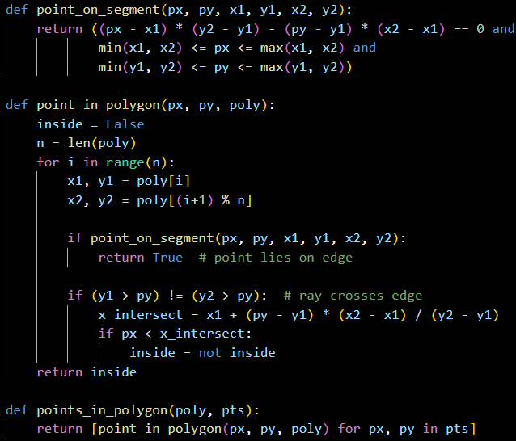

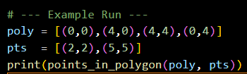

**OUTPUT:**

**C:\Users\lenovo\Pictures\Screenshots\Screenshot 2025-09-17 092923.png**

**OBSERVATION:**

• (2,2) lies inside the square → True.

• (5,5) lies outside → False.

• Points **on polygon edges** are correctly counted as **inside**.

O2)

**Prompt:**

Compute the **rolling median** of a list with sliding window size w=3.  
Return the median of each window. Ensure efficiency (use bisect for maintaining a sorted window).

**CODE:**

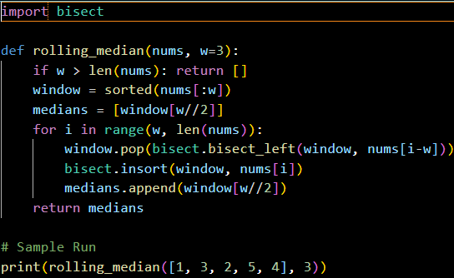

**OUTPUT:**



**OBSERVATION:**

• Maintains a **sorted window** using bisect.

• (1,3,2) → 2, (3,2,5) → 3, (2,5,4) → 4.

• Efficient for moderate inputs, edge-friendly (returns [] if not enough elements).